Lesson 4 - Rotation through 360 degrees  Maths Obj:  - Learn angles in 360 degrees  - Learn quadrant coordinates  ICT Obj:  - Learn how to input data and use in game  - Learn about random positioning  - Learn basic rotation and movement | 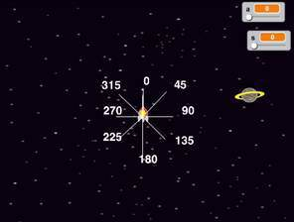

Asset | Initial position | Actions | Movement

Action/initial position/movement | Code Required hints | Maths needed
Random position for planet | 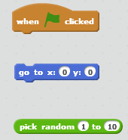
Rotate the earth | 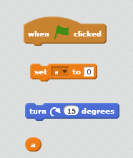
Rotate the missile and shoot | 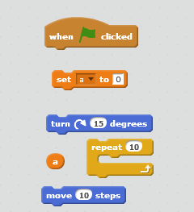
Part 2 – Design your own game
Design another game based on the concept of the previous game. Describe your idea:

What new programming concepts will you use:

Evaluate the Game
Criteria | Score out of 5 | Comment for how to improve
How well did it play?

Did all the programming of Maths work?

Did all the graphic programming work?

Evaluation of the Process
How much maths did you learn? 1 2 3 4 5 How much maths did you apply? 1 2 3 4 5
How much programming did you learn? 1 2 3 4 5 How much did you enjoy it? 1 2 3 4 5

