Asteroid Attack Level 6 Part 1
Obj Maths:  -Use the general formula for gradients  -Use y =mx  -Set random positions on a y-x axis  Obj ICT:  -Learn and use the following loops: it then, repeat and forever  -Develop complex vector based movement | 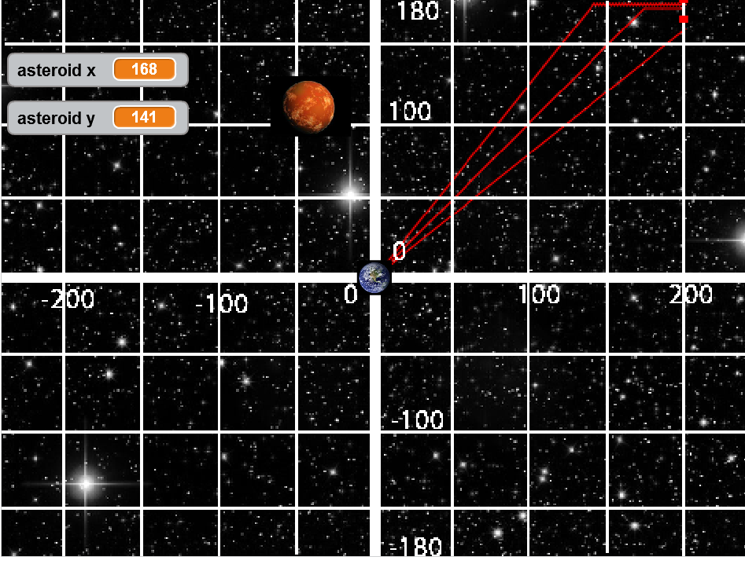
Identify the key assets you will need in the game
Asset | Initial position | Actions | Movement

Identify the Maths You will Need for the Following Actions
Action/initial position/movement | Maths required and any decision conditions
Random asteroid position

Calculate the gradient of the rocket

Drive the rocket

How to place the asteroid in a position not too close to the earth

Evaluate the Game
Criteria | Score out of 5 | Comment for how to improve
How well did it play?

Did all the programming of Maths work?

Did all the graphic programming work?

Evaluation of the Process
How much maths did you learn? 1 2 3 4 5 How much maths did you apply? 1 2 3 4 5
How much programming did you learn? 1 2 3 4 5 How much did you enjoy it? 1 2 3 4 5

