Code Hints y=mx & y=mx+c Project
Asteroids in random start places | 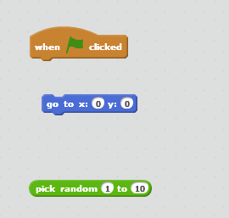
Earth in random start along y axis | 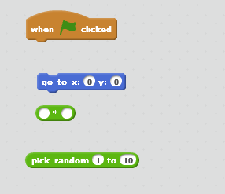
Missiles being shot along y=mx line | 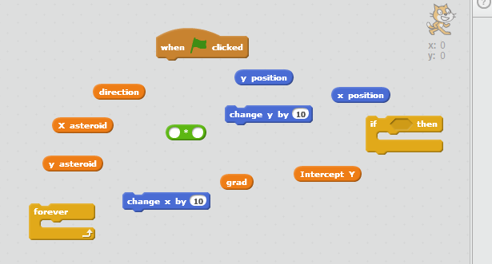
Missiles being shot along y=mx+c | 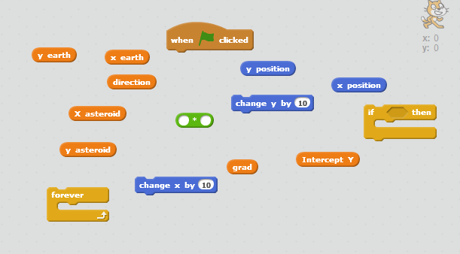
Changing costume | 